

Software Engineering Department

Capstone Project Phase B

Citation Anomaly Detection via Lorentzian Embeddings and Temporal Attention

25-2-R-3

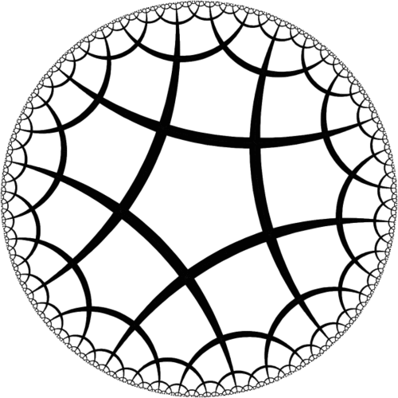

Nadir Yaakov
Ben Zacai

Supervisor: Dr. Dvora Toledano-Kitai
GitHub

Abstract 3
1. Introduction 3
2. Theoretical Background and Problem Overview 4
2.1. Citation networks: Structure, Dynamics, and Challenges 4
2.1.1 Citation Networks Anomalies 5
2.1.2 Limitations of Traditional Methods 5
2.2 Preliminaries 6
2.3 Problem Formulation 7
3. Research Process and System Implementation 8
3.1 Proposed Approach 8
3.2 Data Preparation 8
3.3 System Implementation and Technical Breakdown 9
3.3.1 The System Components 9
3.3.2 Technology Stack 12
3.4 Research Process 12
3. 5 Challenges During Implementation 13
3.5.1 Analytical Challenges-Dynamic Adaptation of L²GC: 13
3.5.2 Engineering Challenges 13
4. Results and Conclusions 14
4.1 Results and Evaluation 14
4.1.1. Quantitative Metrics 14
4.1.2 Visual Analysis and Graph-Based Interpretation 14
4.2 Conclusions and Future Work 18
4.2.1 Conclusions 18
4.2.2 Future Work 18
Appendix 2.1 – User Guide 20
2.1.1. Introduction 20
2.1.2. System Purpose 20
2.1.3. Required Inputs 20
2.1.44. How to Use the System 21
5. Interpretation of Results 23
6. Summary 23
Appendix 2.2 – Maintenance Guide 24
2.2.1. Introduction 24
2.2.2. System Architecture Overview 24
2.2.3. Directory and File Structure 25
2.2.4. Key Files 25
2.2.4.1 model.py 26
2.2.4.2 main.py 26
2.2.5. How to Modify Components 26
2.2.5.1 Changing Temporal Window Size 26
2.2.5.2 Changing L²GC Parameters 27
2.2.5.3 Editing Feature Engineering 27
2.2.5.4 Switching Anomaly Detector 27
2.2.6. Maintenance Best Practices 28
2.2.7. Summary 28
Appendix 2.3 - The L²GC Model 28
2.3.1 Parameter-Free Neighborhood Feature Propagation in Euclidean Space 29
2.3.2 Lorentzian Linear Feature Transformation in Hyperbolic Space 30
2.3.3 Node labels prediction in Euclidean space 31

Abstract
Scientific citation networks are growing exponentially, creating a need for automated tools to detect manipulative behaviors such as citation cartels, coordinated spikes, and excessive self-citation. Traditional Euclidean graph embedding methods fail to capture the hierarchical and dynamic nature of these networks. This project presents an end-to-end anomaly detection system that leverages Lorentzian Linear Graph Convolution (L²GC) to embed citation snapshots from Semantic Scholar into hyperbolic space, preserving hierarchical structures. By integrating a temporal analysis mechanism, the system tracks the evolution of embeddings over time to identify structural drift associated with anomalous behavior. Validated against synthetic anomalies, the system achieves a Precision of 0.90 and an F1-score of 0.85, highlighting the effectiveness of hyperbolic geometry in modeling complex citation dynamics.

1. Introduction
The analysis of scholarly citation networks has become a crucial methodology in understanding how knowledge is produced, disseminated, and evaluated within the academic community. By representing papers as nodes and citations as directed edges, these networks capture the intricate dynamics of scholarly communication, enabling the identification of patterns related to academic influence, intellectual evolution, and research trends (Radicchi, Fortunato, & Vespignani, 2012).
However, as citation networks continue to expand in both size and complexity, new challenges emerge, particularly in identifying atypical or anomalous citation behavior. Such anomalies may include sudden citation spikes, excessive self-citation, or the emergence of artificially dense citation clusters. These patterns could signal scientific misconduct, attempts to manipulate bibliometric indicators, or conversely, may reflect emerging trends or overlooked but influential research contributions (Ciotti et al., 2016).
Traditional graph analysis techniques and shallow embedding methods, such as matrix factorization or random walk-based models, often fall short in capturing the rich hierarchical and temporal properties inherent in real-world citation networks (Goyal & Ferrara, 2018; Xu, 2021). Recent advancements in Graph Neural Networks (GNNs) and hyperbolic representation learning offer more expressive and structured frameworks for modeling complex network data (Zhang et al., 2019). Hyperbolic geometry aligns well with the tree-like and hierarchical nature of citation graphs, enabling better preservation of global relationships in lower-dimensional space (Cannon et al., 1997).
One notable model in this domain is the Lorentzian Linear Graph Convolutional Network (L²GC), which operates in Lorentzian hyperbolic space and has demonstrated strong performance in representing static graphs with hierarchical structure (Liang, Wang, Bao, & Gao, 2024). However, its current formulation is limited to static graphs and does not account for the evolving nature of citation networks over time.
This project proposes a focused framework for anomaly detection in evolving citation networks by extending the Lorentzian Linear Graph Convolutional (L²GC) model, originally designed for static graphs, into a temporal setting. Specifically, the citation network is decomposed into a sequence of time-based snapshots (e.g., by year), applying the L²GC model independently to each temporal subgraph, and tracking the evolution of node embeddings over time. By tracking changes in hyperbolic embeddings across consecutive snapshots, this framework enables the detection of anomalous citation behavior that manifests as abrupt structural or temporal deviations (Xu, Ruan, Korpeoglu, Kumar, & Achan, 2020).
To validate the effectiveness of the proposed approach in the absence of labeled data, we introduce a controlled synthetic anomaly injection strategy, allowing quantitative assessment using standard anomaly detection metrics. By integrating temporal modeling, hyperbolic representation learning, and unsupervised anomaly detection, this project offers a robust, scalable, and geometry-aware framework for uncovering subtle, time-dependent irregularities in scholarly citation networks, enhancing the understanding of scholarly behavior and contributing to research integrity at scale.
The remainder of this document is organized as follows: Section 2 provides the theoretical background on citation networks, documented anomalies, and the geometric rationale for using Lorentzian embeddings to capture hierarchical expansion. Section 3 details the research process and system implementation, describing the five core technical subsystems—from the data preparation pipeline to the evaluation infrastructure. Section 4 presents a comprehensive analysis of the results, including quantitative performance metrics and visual interpretations of the hyperbolic embedding space via t-SNE projections. Finally, Section 4.2 (and subsequent appendices) outlines conclusions, potential enhancements such as neural temporal attention, and provides a detailed user and maintenance guide for the system.

2. Theoretical Background and Problem Overview

2.1. Citation networks: Structure, Dynamics, and Challenges
Citation networks constitute the fundamental data structure for modeling the evolution of scientific knowledge. Formally, a citation network is a directed graph G=(V, E) where each node v∈V represents a scientific paper and each directed edge (u,v)∈E denotes that paper u cites paper v. This directionality encodes the flow of knowledge, intellectual influence, and attribution of credit within the scholarly ecosystem.
Unlike random or static graphs, citation networks exhibit a combination of hierarchical organization, scale-free connectivity, and strict temporal causality. First, knowledge typically propagates from older, foundational works toward newer, specialized papers, forming tree-like structures where seminal papers act as roots. Second, they display a scale-free degree distribution where a small fraction of "hub" papers accumulates a disproportionate number of citations. Third, they are inherently temporal and causal; a paper can only cite works published at time t < T, creating a directed acyclic structure that expands irreversibly from its historical core.
From a geometric perspective, these properties imply that citation networks behave like exponentially expanding hierarchies. Euclidean space, which grows only polynomially with distance, is fundamentally mismatched to this pattern, often causing distinct hierarchical layers to collapse onto one another and obscuring structural anomalies. Hyperbolic geometry, specifically the Lorentz (Hyperboloid) Model, addresses this by providing intrinsic exponential volume growth and constant negative curvature (k < 0). This allows for the preservation of both global hierarchy and local neighborhood similarity with significantly lower distortion than Euclidean embeddings.
Crucially, the temporal nature of citation networks introduces a dynamic dimension that cannot be ignored. Under normal scholarly evolution, a paper’s position within the embedding space evolves gradually, reflecting incremental accumulation of influence and contextual integration into literature. In contrast, abnormal citation behaviors, such as citation cartels, coordinated spikes, or metric manipulation, often induce abrupt and structurally inconsistent changes in a node’s geometric representation. Modeling citation networks as a sequence of temporal snapshots therefore enables the characterization of node trajectories over time, where anomalous behavior can be identified as implausible geometric drift, where a node’s trajectory exhibits implausible velocity or discontinuity within the manifold.

2.1.1 Citation Networks Anomalies
Citation network anomalies refer to citation patterns that deviate significantly from expected structural and temporal evolution of scholarly communication.
Common categories include:
- Sudden Unjustified Citation Spikes: Paper experiencing a rapid, inorganic accumulation of citations, often driven by coordinated manipulation.
- Citation Cartels and Rings: Clusters of authors or journals that reciprocally cite one another to boost collective metrics, forming dense intra-group loops that deviate from organic scientific growth.
- Excessive Self-Citation: Authors disproportionately citing their previous work to inflate personal impact metrics.
- Cross-Domain Irregularities: Papers citing irrelevant works from unrelated fields, sometimes indicative of automated text generation or low-quality "paper mills".
From a network perspective, these behaviors introduce structural and temporal signatures that diverge from organic citation growth, motivating models capable of jointly capturing network hierarchy, local neighborhoods, and temporal evolution.

2.1.2 Limitations of Traditional Methods
Despite extensive research on anomaly detection in graphs, existing approaches often face fundamental limitations when applied to evolving citation networks:
- Geometric Mismatch in Euclidean Embeddings: Most traditional embedding methods, including standard Graph Convolutional Networks (GCNs), operate in Euclidean space, which poorly represents exponentially expanding, hierarchical structures.
- Static Graph Assumptions: Many anomaly detection methods analyze graphs as fixed snapshots, neglecting temporal dynamics where anomalies emerge.
- Scarcity of Labeled Anomalies: Verified anomalous citation behavior is rare and typically undocumented, necessitating unsupervised detection mechanisms capable of identifying deviations without explicit labels.
Building upon these structural and temporal properties, it becomes necessary to formalize the key mathematical definitions, notations, and modeling components that underpin the proposed anomaly detection framework. The following section introduces these preliminaries, including formal notations, hyperbolic embeddings, and the Isolation Forest model employed for detecting anomalous behaviors in evolving citation networks.

2.2 Preliminaries

To formalize the framework, we introduce the main definitions, notations, and modeling components employed in this study.

Dynamic Citation Network and Temporal Snapshots

A dynamic citation network is represented as a sequence of directed graphs

$G=\left\{G_{1},G_{2},...,G_{T}\right\}$ , $G_{t}=\left(V_{t},E_{t}\right)$

where each snapshot $G_{t}$​ corresponds to the citation network at time t. Nodes ${v∈V}_{t}$​ represent papers, and edges $\left(u,v\right)∈E_{t}$​ indicate that paper u cites paper v. This temporal representation allows tracking the evolution of scholarly influence and capturing changes in node embeddings over time.

Hyperbolic Embedding in Lorentzian Space
Each snapshot node ${v∈V}_{t}$ ​ is mapped to a point $x_{v}^{t}{∈H}_{n}$, the n-dimensional Lorentzian hyperboloid of curvature k<0, embedded in Minkowski space $R^{n+1}$. Distances between nodes are computed using the Lorentzian inner product:
${⟨x, y⟩}_{L}= −x₀y₀ + ∑ⁿᵢ₌₁ xᵢyᵢ$
This metric efficiently encodes hierarchical depth and long-range structural differences. Because standard neural operations cannot be performed directly on the curved manifold, the framework implements the Lorentzian Linear Graph Convolutional Network (L²GC). Linear operations are performed in the tangent space: logarithmic maps project points into local Euclidean approximations for transformations, and exponential maps return the transformed vectors to the hyperbolic manifold (Liang et al., 2024).
Node Features and Dynamic Representation
each node v is associated with a feature vector $f_{v}^{t}$​, encoding textual, bibliometric, or contextual information. The temporal embedding $h_{v}^{t}$ combines structural and feature-based representations, capturing the evolution of each node across consecutive snapshots.

Anomaly Detection Model: Isolation Forest (IF)
To identify irregular citation behaviors, the framework employs Isolation Forest (IF). IF assigns an anomaly score to each node based on how easily it can be isolated from the general population of embeddings in hyperbolic space. Nodes with atypical embedding trajectories, whether due to abrupt structural changes or temporal irregularities, are assigned higher scores, enabling unsupervised detection without labeled anomalies.
This section establishes the formal notation, the embedding framework, and the anomaly detection methodology, providing a foundation for the Problem Formulation in the following section.

2.3 Problem Formulation
The primary goal of this study is to detect anomalous citation behaviors in evolving scholarly networks. Formally, given a dynamic citation network represented as a sequence of snapshots $G=\left\{G_{1},G_{2},...,G_{T}\right\}$, we aim to detect nodes whose citation patterns deviate significantly from expected structural and temporal evolution.
Key objectives include:
- Detecting structural anomalies: identifying papers whose citation connections do not conform to the typical hierarchical and scale-free patterns of scholarly networks.
- Detecting temporal anomalies: identifying abrupt changes in citation activity or influence that diverge from the gradual evolution expected in scholarly communication.
- Characterizing anomalous nodes: providing a principled distinction between organic scholarly behavior and irregular patterns that may indicate manipulation, coordination, or other atypical dynamics.
The outcome of this formulation is a set of nodes (papers) flagged as exhibiting unusual citation behavior across time, forming the foundation for subsequent modeling and anomaly detection steps.

These definitions, notations, and formal representations establish the foundation for framing the problem of anomaly detection in evolving citation networks, providing the necessary context for a precise problem formulation in the following section.

3. Research Process and System Implementation
This chapter presents the proposed system for anomaly detection in dynamic citation networks, detailing its conceptual approach, data preparation pipeline, system architecture, development process, and implementation challenges.

3.1 Proposed Approach
The system is an end-to-end anomaly detection framework for scientific citation networks. It learns hyperbolic embeddings of papers, tracks their temporal evolution, and flags anomalous citation patterns.
Key components of the proposed approach:
- Hyperbolic Embedding Module (L²GC Engine)
- Projects node features into a hyperbolic manifold using Lorentzian Linear Graph Convolution.
- Aggregates neighbor information while preserving hierarchical relationships.
- Uses logarithmic and exponential maps for operations in tangent spaces.
- Temporal Evolution Analyzer
- Tracks node embedding trajectories across consecutive snapshots.
- Computes drift vectors to detect abnormal temporal behavior (e.g., sudden citation spikes).
- Anomaly Detection Engine
- Embeddings are projected to a tangent space for classical anomaly detection.
- Isolation Forest identifies nodes with abnormal geometric behavior.
- The contamination parameter is set based on synthetic injections and estimated natural anomalies.
The use of Isolation Forest is further detailed in the implementation stage.

3.2 Data Preparation

The dataset was derived from DBLP version 13, which contains over 5.3 million papers and 48.2 million citations. To create a manageable subset for experimental evaluation:

Filtering and Selection
- Three primary domains were selected: Computer Science, Nonlinear Systems, and Artificial Intelligence.
- Papers were retained only if they contained a non-empty abstract and at least one citation.
The resulting dataset comprises 11,409 papers (nodes) and 10,780 citations (edges) spanning 61 years (1959–2020). Each paper includes the following fields: id, title, authors, year, field of study, citation count, references, and abstract.

Feature Extraction:
- Node features were computed using TF-IDF vectors for titles, abstracts, and authors’ names.
- These vectors provide numerical input for the hyperbolic embedding module.
·
Temporal Segmentation:
- The dataset was divided into cumulative or windowed snapshots (e.g., 2000–2005, 2006–2010), enabling analysis of temporal evolution.

Note: This section describes the conceptual design of the dataset and feature construction, while the operational realization of these steps is detailed in Section 3.3 as part of the system implementation.

3.3 System Implementation and Technical Breakdown
Building on the prepared dataset and temporal graph structure (Section 3.2), this section describes the practical realization of the proposed framework. It details the operational execution of the data preparation pipeline, hyperbolic embedding module, temporal analysis, anomaly detection engine, and evaluation infrastructure. The implementation is designed to support large-scale, sparse, and temporally evolving citation networks while maintaining computational efficiency and geometric consistency across snapshots.
The L²GC module, introduced in Section 3.1, was implemented with consideration for dynamic graphs, which required specific adaptations during development (see Section 3.4). The system architecture is organized as a modular pipeline composed of five interconnected subsystems, each responsible for a distinct stage in the anomaly detection process.

3.3.1 The System Components
Component 1: Data Loader and Preprocessing Pipeline

- Static Feature Extraction: Each paper is represented by a feature vector derived from its title, abstract, and authors’ names using TF-IDF, alongside numerical metadata such as publication year and field of study.
- Graph Construction: Directed citation edges are encoded using sparse adjacency matrices and edge indices compatible with PyTorch Geometric.
- Temporal Segmentation: The citation network is partitioned into cumulative or windowed temporal snapshots (e.g., 2000–2005, 2006–2010), enabling the analysis of network evolution over time.
This component establishes the temporal graph structure and feature space used throughout the system.
Component 2: Hyperbolic Embedding Module (L²GC Engine)
This core module generates hyperbolic representations of papers using the Lorentzian Linear Graph Convolutional Network (L²GC).
- Geometric Rationale: Citation networks exhibit hierarchical and tree-like structures, which are naturally captured in hyperbolic space with constant negative curvature.
- Convolutional Process:
o Node features are projected into the tangent space via the logarithmic map.
o Learnable linear transformations are applied in tangent space.
o The transformed vectors are mapped back onto the hyperbolic manifold using the exponential map.
o Neighbor information is aggregated using hyperbolic distance-aware message passing.
- Implementation: Riemannian optimization and manifold operations are implemented using the geoopt library in PyTorch.
This module produces geometry-aware embeddings that preserve hierarchical relationships in citation networks.
Component 3: Temporal Evolution Analyzer
This module models the temporal dynamics of citation behavior by tracking node embeddings across consecutive snapshots.
For each paper, its embedding at snapshot $T$ is compared with its embedding at snapshot $T$+1, yielding a drift vector that captures geometric displacement over time.
Under organic scholarly evolution, these trajectories tend to be smooth and gradual. In contrast, anomalous behaviors, such as sudden citation bursts or coordinated manipulation, often manifest as abrupt shifts or irregular geometric acceleration within the hyperbolic manifold.
Component 4: Anomaly Detection Engine
To enable the use of classical anomaly detection algorithms, hyperbolic embeddings are projected into a unified tangent space.
- Algorithm: Isolation Forest is employed due to its effectiveness in high-dimensional, unlabeled settings. It isolates observations by recursively partitioning the feature space; anomalous nodes typically require fewer splits to be isolated.
- Contamination Strategy: The contamination parameter is set based on the sum of the synthetic injection ratio and an estimated baseline level of natural anomalies. For example, a 5% synthetic injection combined with a 1% baseline anomaly rate yields a contamination value reflecting this combined proportion.
- Output: Each paper receives an anomaly score, and nodes exceeding the threshold determined by the contamination parameter are flagged as anomalous.
The tangent space projection ensures compatibility between hyperbolic embeddings and Euclidean-based detection methods.
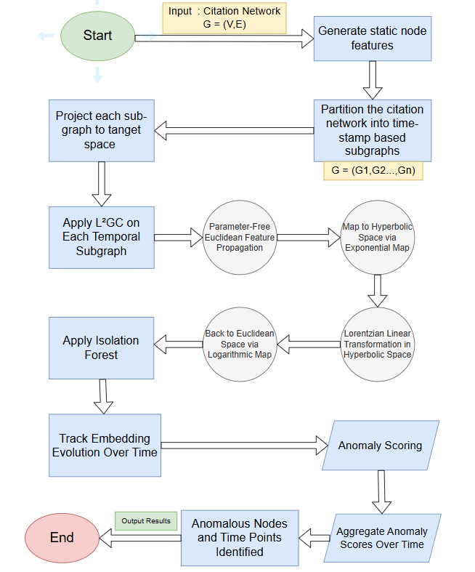
Fig.1 Full process of finding anomalies from the given citation network

Component 5: Evaluation and Reporting Layer
This component manages validation and performance assessment using a post-hoc static evaluation strategy.
Training Phase: The model is trained exclusively on real citation data up to the final temporal snapshot.
Frozen Encoder: Feature extractors, scalers, and L²GC weights are frozen after training to prevent data leakage.
Synthetic Injection: Synthetic anomalous papers are injected only at the final timestamp and embedded using the frozen encoder.
Scoring and Evaluation: Anomaly scores are computed jointly for real and synthetic papers, allowing quantitative evaluation of the model’s ability to detect previously unseen anomalous behavior.
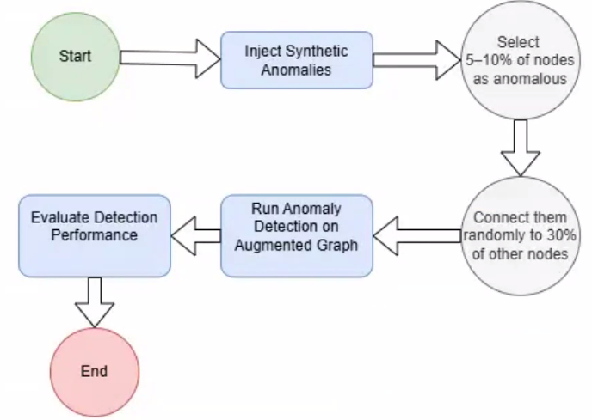
Fig.2 The validation process injecting synthetic anomalies for precision evaluation

3.3.2 Technology Stack
The system was implemented using a set of complementary tools and frameworks to support dynamic graph processing, hyperbolic embedding, and anomaly detection:
- Orchestration: Python 3.9, compatible with all selected libraries.
- Deep Learning Framework: PyTorch supporting dynamic computation graphs.
- Graph Processing: PyTorch Geometric for efficient handling of sparse and dynamic graph data.
- Manifold Optimization: Geoopt for hyperbolic and Riemannian operations.
- Graph Analysis: NetworkX for structural and topological analysis.
- Anomaly Detection: Scikit-learn’s Isolation Forest.
- Hardware: GPU acceleration via CUDA on Google Colab and local workstations.

3.4 Research Process
The development followed an iterative engineering workflow designed for dynamic citation networks:
1. L²GC Adaptation:
Static open-source implementations on L²GC were extended to support dynamic graphs by enabling variable adjacency matrices and node sets across snapshots.

2. Temporal Analysis Development:
- A persistent node identification mechanism was implemented to ensure correct mapping of nodes across snapshots.
- Drift vectors were calculated to capture anomalous temporal patterns.

3. Synthetic Validation Design:
A semi-synthetic anomaly injection module was developed to enable quantitative evaluation in the absence of labeled data:
- Semi-synthetic anomalies were injected with post-training at the final snapshot.
- Synthetic nodes undergo the same preprocessing pipeline as real nodes (TF-IDF vectorization, scaling, encoding). This setup evaluates whether the frozen encoder can detect out-of-distribution anomalies without prior exposure.

3. 5 Challenges During Implementation

3.5.1 Analytical Challenges-Dynamic Adaptation of L²GC:
- Challenge: Standard L²GC is designed for static graphs. Maintaining temporal coherence while adapting to dynamic snapshots was difficult.
- Solution: Each snapshot $T$ is processed independently while initializing weights from the convergence state of snapshot $T$ - 1, ensuring continuity in embeddings.

3.5.2 Engineering Challenges
- Computational Cost: Hyperbolic operations (logarithmic/exponential maps) are expensive.
Solution: Full GPU acceleration and optimized batch sizes maximize VRAM utilization.
- Sparsity and Scale: Large citation matrices can cause memory overflows.
Solution: PyTorch Geometric’s SparseTensor allows message passing without densifying the adjacency matrix.
- Contamination Parameter Tuning: Correct contamination in Isolation Forest is critical.
Solution: Multiple runs with varying contamination values determine the optimal setting.
- Collaborative Workflow: Initial development on a single PC limited team collaboration.
Solution: Established a shared pipeline in Google Colab to enable multi-user collaboration.

4. Results and Conclusions

4.1 Results and Evaluation

4.1.1. Quantitative Metrics
The performance of the proposed anomaly detection framework was quantitatively evaluated using the post-hoc synthetic injection method described in Section 2.
This evaluation setting is designed to assess the model’s ability to distinguish organically evolving citation patterns from artificially injected anomalous behaviors introduced only at the final temporal snapshot.
The anomaly detection engine based on Isolation Forest demonstrated strong discrimination capability between the learned organic patterns and the injected synthetic anomalies. As reported in Table 1, the model achieved a recall of 0.9357, indicating that the majority of injected anomalies were successfully identified. The precision score of 0.8321 reflects a moderate presence of false positives, which is generally acceptable in anomaly detection scenarios where failing to detect anomalous behavior is considered more costly than over-flagging normal instances. The resulting F1 score of 0.8809 confirms a balanced and robust overall performance of the proposed framework under the evaluated setting.

Metric | Score
Precision | 0.8321
Recall | 0.9357
F1 Score | 0.8809

Table 1. Quantitative performance of the anomaly detection model under post-hoc synthetic injection.

4.1.2 Visual Analysis and Graph-Based Interpretation
To qualitatively complement the quantitative evaluation, we analyzed the
structure of the learned embedding space and the distribution of anomaly scores through
visual inspection. These visualizations provide intuitive insight into how the model
separates organically evolving citation patterns from anomalous behaviors.

t-SNE Visualization of Hyperbolic Embeddings
Figure 3 presents a two-dimensional e t-SNE projection of the learned embeddings in the tangent space. The visualization reveals a clear geometric separation between real and synthetic papers. Real papers (marked in blue) form a dense and coherent cluster, reflecting the structured and hierarchical nature of organic citation dynamics. In contrast, synthetic papers (marked in red) appear as a compact yet distinctly separated group, indicating that their embeddings deviate consistently from the learned citation geometry.
This separation suggests that the L²GC-based hyperbolic embedding successfully encodes structural regularities of citation networks, while anomalous patterns, introduced through synthetic injection, are mapped to regions of the embedding space that are geometrically inconsistent with organic scholarly evolution. The observed clustering behavior aligns with the high recall and F1-score reported in Section 4.1, providing qualitative support for the effectiveness of the proposed framework.

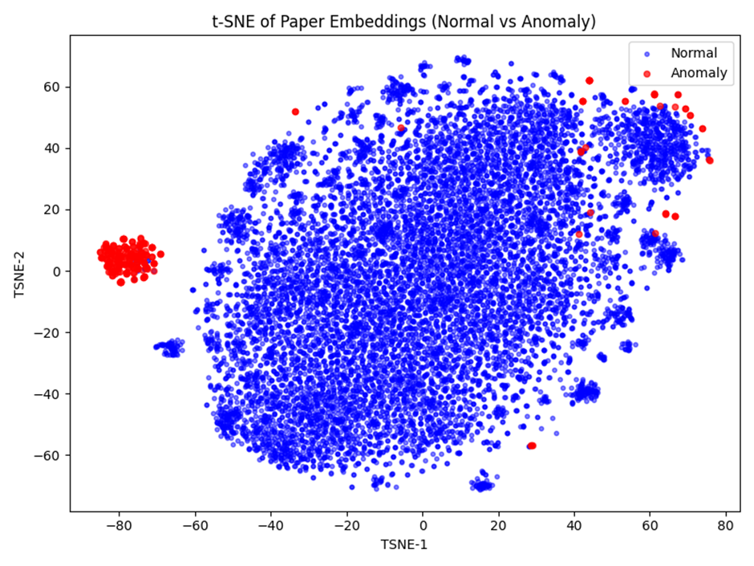
Fig.3 t-SNE algorithm output
Anomaly Score Distribution
Figure 4. presents the distribution of Isolation Forest scores for real (blue) and synthetic (red) papers. A clear separation between the two distributions is observed, with minimal overlap near the decision boundary. Real papers consistently achieve high anomaly scores, reflecting stable and coherent citation behavior learned by the model, while synthetic papers are concentrated around significantly lower scores.
This clear separation indicates that the learned hyperbolic representations effectively encode structural regularities of organic citation dynamics, enabling the anomaly detector to distinguish injected anomalies using a simple thresholding strategy. The limited overlap further suggests that the detection performance is robust and not driven by marginal score differences.
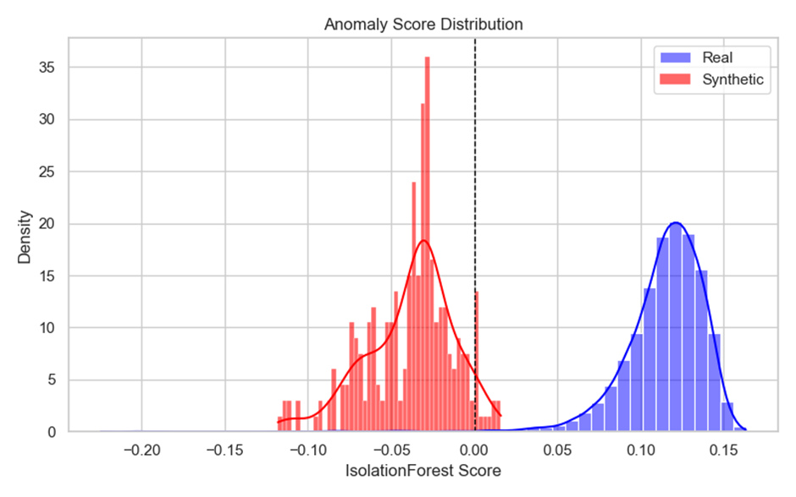
Fig.4 Distribution of Isolation Forest Anomaly Scores for Real and Synthetic Papers
Citation Count vs. Anomaly Score
Figure 5 examines the relationship between citation count and anomaly score for real and synthetic papers. Although synthetic papers (red) are primarily concentrated at very low citation counts, the figure also reveals a substantial number of real papers (blue) with similarly low citation volumes. Despite this overlap in citation counts, the model correctly assigns higher anomaly scores (indicating normal behavior) to real papers and lower scores to synthetic ones. This observation demonstrates that anomaly detection is not driven by raw citation frequency alone, but rather by the underlying structural and geometric patterns captured in the hyperbolic embedding space.
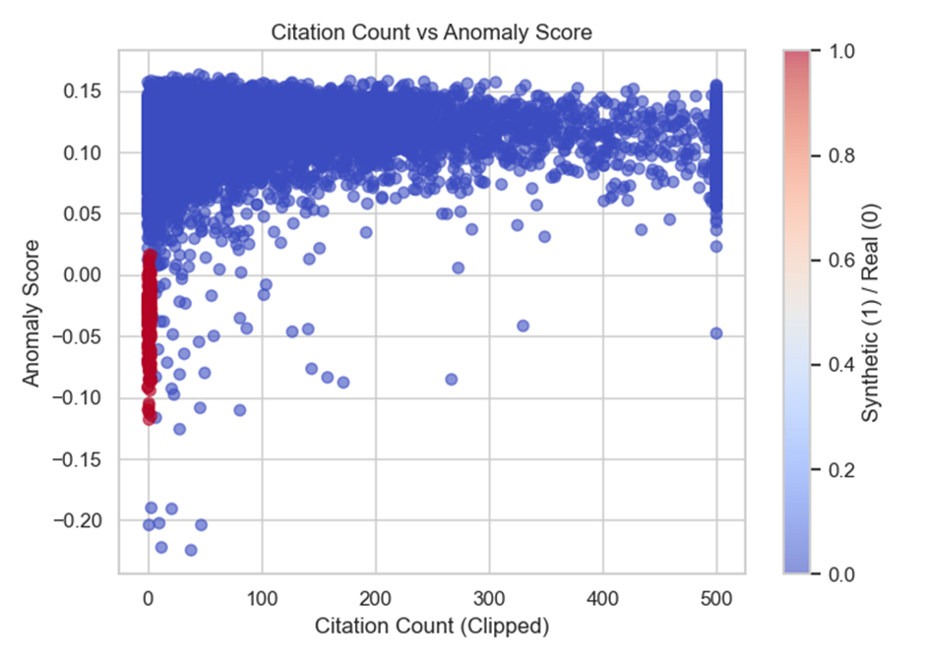
Fig.5 Citation Count versus Anomaly Score
Confusion Matrix
The confusion matrix in Figure.6 summarizes the classification performance on the validation set. The model correctly identifies 233 synthetic papers as anomalous (true positives) and classifies 11,362 real papers as normal (true negatives). Only 16 synthetic papers are missed (false negatives), while 47 real papers are incorrectly flagged as anomalous (false positives). These results indicate strong discriminative capability with a low false-positive rate.

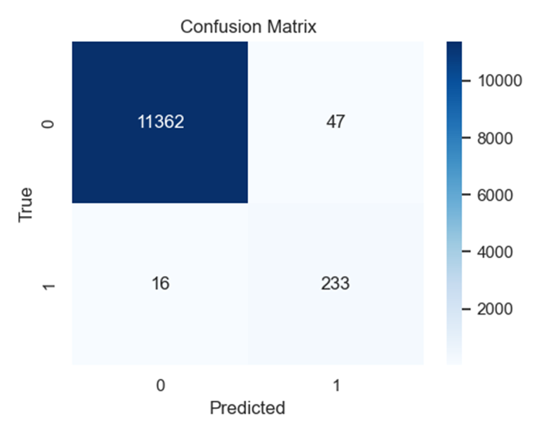
Fig. 6 Confusion Matrix for Synthetic Anomaly Detection

4.2 Conclusions and Future Work

4.2.1 Conclusions
Phase B successfully produced a functional and validated software artifact for anomaly detection in citation networks. Quantitative evaluation shows strong performance, with an F1 score of 0.8809, recall of 0.9357, and precision of 0.8321, indicating effective identification of injected synthetic anomalies while maintaining a moderate false-positive rate. Visual inspection of the learned hyperbolic embeddings via t-SNE projections confirms a clear geometric separation between real and synthetic papers, illustrating that the model captures the structural and hierarchical regularities of organic citation patterns.
Further analysis of Isolation Forest scores and the relationship between citation counts and anomaly scores demonstrates that detection relies on structural and geometric characteristics rather than raw citation volume alone. Overall, the combination of quantitative metrics and visualizations confirms that the L²GC-based hyperbolic embedding framework robustly identifies anomalous citation behaviors without requiring labeled anomalies during training, highlighting its potential for unsupervised anomaly detection in evolving scholarly networks.

4.2.2 Future Work
To further enhance the system, future iterations could focus on the following directions:
- Scalability: Migrating the pipeline to distributed graph processing frameworks (e.g., DGL or PySpark) to handle massive datasets such as the full Web of Science.
- Neural Temporal Attention: Replacing the current geometric drift tracking with a learnable Attention Mechanism (Transformer-based) to dynamically weigh historical snapshots and better capture temporal dependencies.
- Probabilistic Detection: Exploring the use of Riemannian Gaussian distributions to perform anomaly detection directly in the hyperbolic space, eliminating the need to project embeddings to the tangent space.

References

Liang, Q., Wang, W., Bao, F., & Gao, G. (2024). L2GC: Lorentzian linear graph convolutional networks for node classification (Version 3) [Preprint]. arXiv.
https://arxiv.org/abs/2403.06064

Radicchi, F., Fortunato, S., & Vespignani, A. (2012). Citation networks. In A. Scharnhorst, K. Börner, & P. van den Besselaar (Eds.), Models of science dynamics: Understanding complex systems (pp. 233–257). Springer. https://doi.org/10.1007/978-3-642-23068-4_7

Goyal, P., & Ferrara, E. (2018). Graph embedding techniques, applications, and performance: A survey. Knowledge-Based Systems, 151, 78–94. https://doi.org/10.1016/j.knosys.2018.03.022

Xu, M. (2021). Understanding graph embedding methods and their applications. SIAM Review, 63(4), 825–853. https://doi.org/10.1137/20m1386062

Zhang, S., 1, Tong, H., 1, Xu, J., 2, & Maciejewski, R., 3. (2019). Graph convolutional networks: a comprehensive review. Comput Soc Netw, 2–23. https://doi.org/10.1186/s40649-019-0069-y

Ciotti, V., Bonaventura, M., Nicosia, V., Panzarasa, P., & Latora, V. (2016). Homophily and missing links in citation networks. EPJ Data Science, 5(1). https://doi.org/10.1140/epjds/s13688-016-0068-2

Shibata, N., Kajikawa, Y., & Sakata, I. (2011). Link prediction in citation networks. Journal of the American Society for Information Science and Technology, 63(1), 78–85. https://doi.org/10.1002/asi.21664

CANNON, J. W., J., FLOYD, W. J., KENYON, R., & PARRY, W. R. (1997). Flavors of geometry. In MSRI Publications: Vol. Volume 31. https://library.slmath.org/books/Book31/files/cannon.pdf

Xu, D., Ruan, C., Korpeoglu, E., Kumar, S., & Achan, K. (2020). Inductive representation learning on temporal graphs. arXiv (Cornell University).
https://arxiv.org/pdf/2002.07962

Xu, D., Ruan, C., Korpeoglu, E., Kumar, S., & Achan, K. (2020). Inductive representation learning on temporal graphs. In International Conference on Learning Representations (ICLR).
https://openreview.net/forum?id=rJeW1yHYwH

Appendix 2.1 – User Guide
User Guide – Citation Anomaly Detection System

2.1.1. Introduction
This user guide explains how to operate the citation anomaly detection system implemented in Python.
The system analyzes academic citation graphs, computes hyperbolic embeddings using L²GC, and detects anomalous papers based on temporal embedding behavior.
This guide covers the nominal, successful use-case only.

2.1.2. System Purpose
The system automatically detects abnormal citation behavior by:
- Loading and preprocessing paper metadata
- Building a directed citation graph
- Creating 5-year cumulative temporal snapshots
- Computing hyperbolic embeddings using L²GC
- Injecting synthetic anomalies for validation
- Running Isolation Forest to detect anomalies
- Saving detailed per-paper anomaly results to CSV
The system is intended for researchers, bibliometric analysts, and academic integrity teams.

2.1.3. Required Inputs
The system expects one CSV file containing:
- id – paper identifier
- title
- authors.name
- year
- fos.name
- n_citation (array of paper ids which the paper cites from)
- references (as a Python list inside a string)
- abstract
The file must be placed at the path specified in the script header.

2.1.44. How to Use the System
Step 1 – Launch the UI
run in terminal:
streamlit run ui.py
Step 2 – Load the dataset
Drag or input the file into the box that requires it

Step 3 – Run the Script
Run the full pipeline by pressing:
Run Pipeline
Step 4 – System Execution Steps
The script will automatically:
- Load the CSV file
  - Convert references column into Python lists
  - Prepare paper metadata
- Build the citation graph
  - Add each paper as a node
  - Add citation relationships as directed edges
- Extract features
  - TF-IDF features from title + abstract
  - Numerical features (citations, year)
  - One-hot FOS encoding
  - Number of authors
- Segment the graph temporally
  - 5-year cumulative windows
  - Example: 1990–1995, 1995–2000, etc.
- Run L²GC on each time window
  - Compute PageRankAggr propagation
  - Train L²GC with temporal smoothness
  - Generate embeddings
- Anomaly detection (Real run)
  - Isolation Forest with 1% contamination
- Synthetic anomaly validation
  - Inject 2.5% synthetic nodes
  - Connect each fake node to 0-5 nodes of the real nodes
  - Detect anomalies with dynamic threshold
- Save results to CSV
Step 5 – View the Output
After execution completes, the system produces:
temporal_anomaly_results.csv

This file contains:
- Paper ID
- Time segment (start/end year)
- Anomaly score
- Predicted label (1 normal, -1 anomaly)
- Synthetic flag
This file is your main output for analysis.

5. Interpretation of Results
A paper is anomalous if:
- It receives an anomaly label -1
- Its anomaly score is low (more negative)
- Its embedding jumps significantly between time windows
- It behaves similarly to synthetic anomaly patterns
Because this is unsupervised, high anomaly scores indicate outliers in the embedding space.

6. Summary
This user guide explains how to operate the full citation anomaly detection pipeline.
The user only needs to:
- Provide the input CSV
- Run the script
- Review the generated CSV output
All other steps are automated.

Appendix 2.2 – Maintenance Guide

2.2.1. Introduction
This Maintenance Guide describes how to update, modify, and extend the anomaly detection system.
It is intended for developers and maintainers.

2.2.2. System Architecture Overview
Your code implements the following major components:
- Data Loading and Preprocessing
  - CSV ingestion
  - Conversion of references
- Graph Construction
  - Nodes = papers
  - Edges = citations
  - Uses NetworkX
- Feature Engineering
  - TF-IDF from title + abstract
  - Standardized numerical attributes
  - OneHot FOS
  - Author count
- Temporal Segmentation
  - 5-year cumulative segments
- L²GC/ Hyperbolic Embeddings
  - PageRankAgg propagation
  - L²GC model
  - Temporal-smoothness prior
- Anomaly Detection
  - Isolation Forest
  - Dual detection: real + synthetic
- Synthetic Anomaly Injection
  - 5% fake nodes
  - 30% random connectivity
  - Gaussian noise features
- CSV Output Generation

2.2.3. Directory and File Structure
Your folder structure should follow:
LLGC-main/
│
├── model.py (LLGC + PageRankAgg implementation)
├── main.py
├── final_filtered_by_fos_and_reference.csv
├── fakes.csv (fake nodes to be injected)
├── temporal_anomaly_results.csv (output)
└── (additional Python modules if added later)

2.2.4. Key Files

2.2.4.1 model.py
Contains:
- L²GC model
- PageRankAgg propagator
- Manifold operations
Only update if you need to change the embedding model.

2.2.4.2 main.py
Contains:
- Full pipeline
- Feature engineering
- Temporal segmentation
- Dual execution (clean & synthetic)
- Anomaly detection
- CSV saving
This is the main file maintainers modify.

2.2.5. How to Modify Components

2.2.5.1 Changing Temporal Window Size
Edit:
DELTA_T = 5

Setting to 1, 3, or 10 changes the granularity.

2.2.5.2 Changing L²GC Parameters
Inside the parameter section:
K_PROP = 5
ALPHA = 0.8
EMBEDDING_DIM = 128
EPOCHS = 50
LR = 0.01

These can be tuned freely.

2.2.5.3 Editing Feature Engineering
To add/remove features, modify:
- TF-IDF parameters
- Numerical columns
- FOS encoder
- Author extraction logic

2.2.5.4 Switching Anomaly Detector
Currently:
IsolationForest()

Can replace with:
- One-Class SVM
- Local Outlier Factor
- Autoencoder
- Gaussian Mixture
Ensure the new model outputs comparable anomaly scores.

2.2.6. Maintenance Best Practices
- Always test on one time segment first to reduce runtime.
- Do not modify synthetic generation logic unless retraining validation.
- Keep model.py isolated from pipeline logic.
- Use Git to version every change.
- Run with GPU when possible for speed.

2.2.7. Summary
This Maintenance Guide provides the necessary documentation to extend or update:
- Temporal modeling
- L²GC architecture
- Graph construction
- Anomaly detection
- Validation strategy
The system is modular, and maintainers can safely adjust components individually.

Appendix 2.3 - The L²GC Model
The Lorentzian Linear Graph Convolutional Network (L²GC ) is designed to generalize linear graph convolution operations to hyperbolic space, leveraging the representational power of the Lorentz model to encode hierarchical and tree-like structures more effectively. The L²GC framework operates in three main stages, combining both Euclidean and hyperbolic computations:

2.3.1 Parameter-Free Neighborhood Feature Propagation in Euclidean Space
This step constitutes the first step of the L²GC framework. Its goal is to balance the influence of the graph structure and the original node features without relying on any trainable parameters. The procedure is as follows:
- A self-looped graph G̃ is created by adding self-connections to the original graph $G=\left(V,E\right)$ with $n$ nodes and$m$ edges.
- A linear propagation matrix P is computed as
P = (D + I)⁻¹ᐟ² (A + I) (D + I)⁻¹ᐟ²,
where A is the adjacency matrix $G$ and D is the diagonal degree matrix $G$.
- Node features are updated using the information transfer between the node and its n-power neighbors :
H⁽ˡ⁺¹⁾ = (1 − α) P H⁽ˡ⁾ + αX,
where $X∈ℝ^{n×d}$ is the initial node feature matrix, where each node $v∈V$ is associated with a feature vector $x_{v }∈ℝ^{d}$, and $α∈\left[0,1\right]$ is a teleport (or retention) probability that controls the influence of the original features at each propagation step, and l denotes the layer or iteration index.
- This iterative process ensures that each layer representation H⁽ˡ⁾ is influenced by both the graph structure and the initial node features $X$, with a fixed proportion. As a result, the final node representations $H⁽ⁿ⁾$ are derived through n-step propagation, capturing both local and global structural information. This parameter-free propagation scheme blends the initial node features with information from the graph structure at each step, thereby mitigating the over-smoothing effect commonly observed in deep graph convolutional networks.
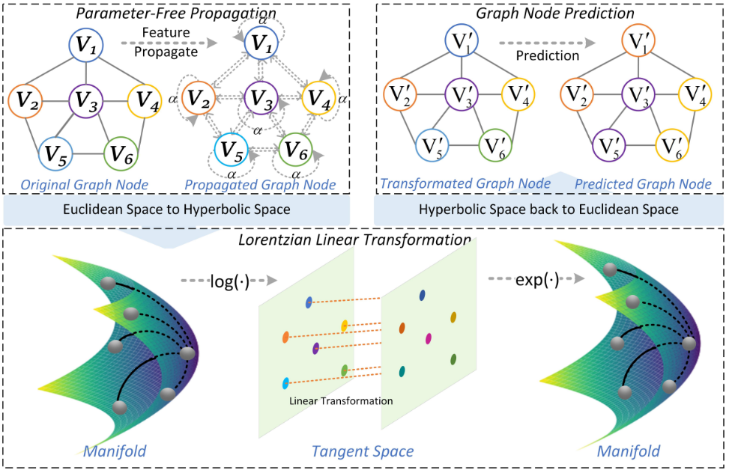
Fig.7: The Parameter-Free Propagation Process (Liang, Wang, Bao, & Gao, 2024).

Fig.8 The framework of Lorentzian Linear Graph Convolutional Networks for node Classification (Liang, Wang, Bao, & Gao, 2024).

2.3.2 Lorentzian Linear Feature Transformation in Hyperbolic Space
After the feature propagation stage, the learned Euclidean node representations $H⁽ⁿ⁾$are mapped into Lorentzian hyperbolic space using the exponential map at the origin, denoted expₖ⁰. This operation yields the initial hyperbolic embeddings:
$x⁽ⁿ⁾=expₖ⁰(H⁽ⁿ⁾)$
Once embedded in hyperbolic space, the L²GC model performs a Lorentzian linear transformation, which serves as the hyperbolic analogue of a standard linear layer in Euclidean GCNs. This transformation is performed through the following sub-steps:
- Logarithmic map: The hyperbolic embeddings $x⁽ⁿ⁾$​ are first mapped back to the tangent space at the origin:
$v=logₖ⁰(x⁽ⁿ⁾)$
- Linear transformation in tangent space: A Euclidean linear transformation is then applied to the spatial (space-like) components (𝑣₁, …, 𝑣ₙ) of the tangent vectors, while leaving the time-like coordinate unchanged:
$\hat{M}$(𝑣) = (0, 𝑀(𝑣₁, …, 𝑣ₙ))
Here $M∈ℝ^{m×n}$ is a learnable weight matrix representing a linear transformation $M$: ℝⁿ → ℝᵐ, applied only to the spatial part in accordance with Lorentzian geometry.

- Exponential map: The transformed vectors are then mapped back to the hyperbolic Lorentz manifold:
$M^{⊗}$(v)= expₖ⁰($\hat{M}$(𝑣))
To summarize the full transformation pipeline, from Euclidean features to their hyperbolic representations after linear transformation, the operations are composed as follows
$M^{⊗}$($H⁽ⁿ⁾$)= expₖ⁰($\hat{M}$(logₖ⁰($expₖ⁰(H⁽ⁿ⁾)$)))
This composite formulation encapsulates the entire process while preserving the geometric consistency of the Lorentzian manifold, thereby enabling expressive and curvature-aware feature transformations within the hyperbolic space.

2.3.3 Node labels prediction in Euclidean space
In its original formulation, the L²GC framework concludes by mapping the transformed hyperbolic embeddings d back to Euclidean space using the logarithmic map
$z=logₖ⁰\left(x_{transformed}\right)$
This mapping allows the application of standard classifiers (e.g., SoftMax layers) for node label prediction. Returning to Euclidean space, ensures compatibility with common loss functions and evaluation metrics, facilitating supervised learning tasks..
By incorporating a Lorentzian linear transformation in hyperbolic space, L²GC leverages the expressive power of non-Euclidean geometry, particularly its capacity to model hierarchical and tree-like structures with lower distortion. As a result, L2GC demonstrates strong performance on datasets characterized by low Gromov $δ$-hyperbolicity, such as citation networks.

